Conical Surface

Definition
# Source: AI Source: Provided by: [Data Path: Persons Table -> ID Column: 1, Name_En Column: Motasem Essam] -> From: [ChatGPT] on [7/20/2026]
A Conical Surface is a curved surface generated by a straight line, called a generator, that passes through a fixed point called the vertex and moves along a fixed curve called the directrix.
In the most common case, the directrix is a circle. This produces a circular conical surface.
A finite circular conical surface consists of the curved lateral surface extending from the circular base to the vertex.
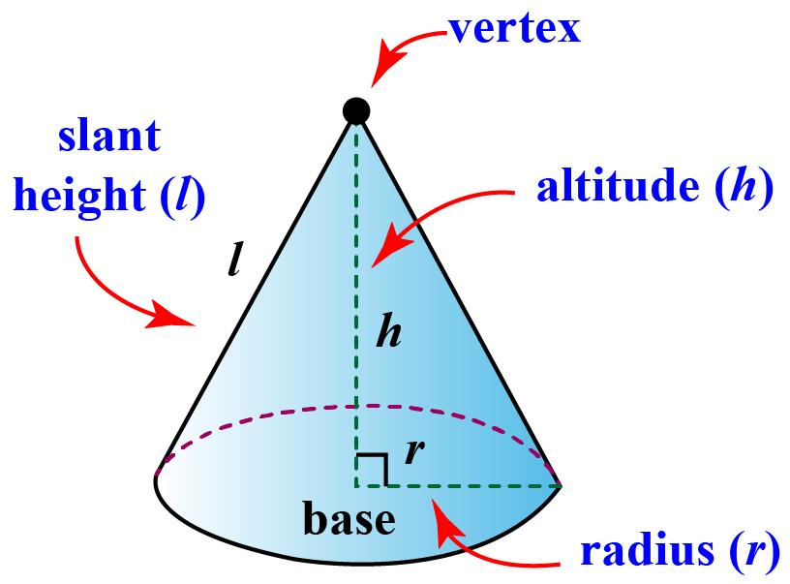
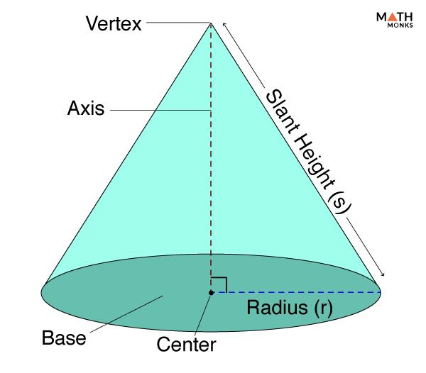
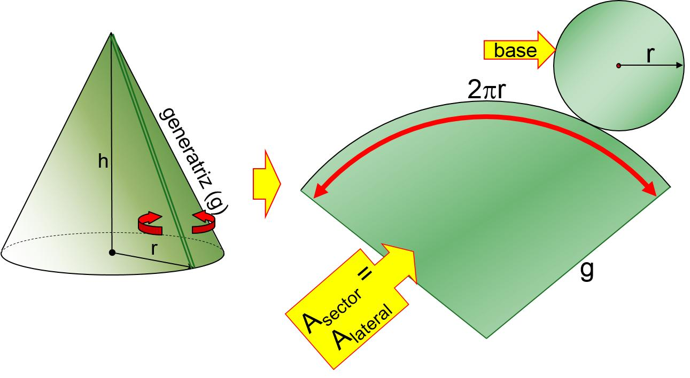
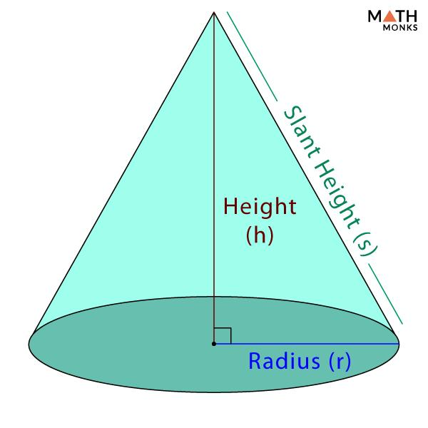
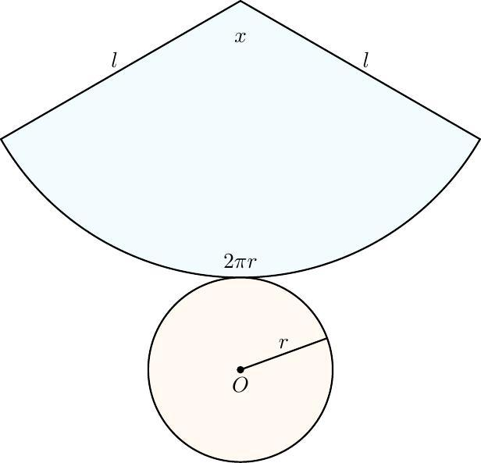
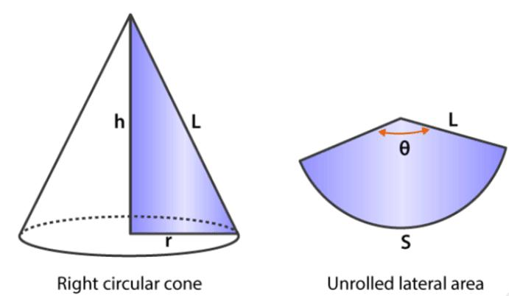

Purpose
# Source: AI Source: Provided by: [Data Path: Persons Table -> ID Column: 1, Name_En Column: Motasem Essam] -> From: [ChatGPT] on [7/20/2026]
A conical surface is used to:
- Describe the curved boundary of a cone.
- Calculate curved surface area.
- Study three-dimensional geometric surfaces.
- Model cone-shaped objects.
- Connect geometry with trigonometry and coordinate geometry.
- Analyze objects such as funnels, cones, roofs, and nozzles.

Fundamental Elements
# Source: AI Source: Provided by: [Data Path: Persons Table -> ID Column: 1, Name_En Column: Motasem Essam] -> From: [ChatGPT] on [7/20/2026]
For a right circular conical surface, the main elements are:

1. Vertex
# Source: AI Source: Provided by: [Data Path: Persons Table -> ID Column: 1, Name_En Column: Motasem Essam] -> From: [ChatGPT] on [7/20/2026]
The vertex, usually denoted by $V$, is the fixed point where all generators meet.

2. Base
# Source: AI Source: Provided by: [Data Path: Persons Table -> ID Column: 1, Name_En Column: Motasem Essam] -> From: [ChatGPT] on [7/20/2026]
The base is the circular region associated with the conical surface.
The circular boundary of the base has radius $r$.

3. Radius
# Source: AI Source: Provided by: [Data Path: Persons Table -> ID Column: 1, Name_En Column: Motasem Essam] -> From: [ChatGPT] on [7/20/2026]
The radius $r$is the radius of the circular base.

4. Height
# Source: AI Source: Provided by: [Data Path: Persons Table -> ID Column: 1, Name_En Column: Motasem Essam] -> From: [ChatGPT] on [7/20/2026]
The height $h$is the perpendicular distance from the vertex to the plane containing the base.

5. Slant Height
# Source: AI Source: Provided by: [Data Path: Persons Table -> ID Column: 1, Name_En Column: Motasem Essam] -> From: [ChatGPT] on [7/20/2026]
The slant height $l$is the distance measured along the conical surface from the vertex to a point on the circular boundary of the base.
For a right circular cone:
$$\boxed{l^{2}=r^{2}+h^{2}}$$
Therefore:
$$\boxed{l=\sqrt{r^{2}+h^{2}}}$$

6. Axis
# Source: AI Source: Provided by: [Data Path: Persons Table -> ID Column: 1, Name_En Column: Motasem Essam] -> From: [ChatGPT] on [7/20/2026]
The axis is the line segment connecting the vertex to the center of the circular base.
For a right circular cone, the axis is perpendicular to the base.

7. Generators
# Source: AI Source: Provided by: [Data Path: Persons Table -> ID Column: 1, Name_En Column: Motasem Essam] -> From: [ChatGPT] on [7/20/2026]
The generators are straight lines from the vertex to points on the directrix.

Mathematical Representation
# Source: AI Source: Provided by: [Data Path: Persons Table -> ID Column: 1, Name_En Column: Motasem Essam] -> From: [ChatGPT] on [7/20/2026]
For a right circular cone with vertex at the origin and axis along the $z$-axis, one possible equation for its lateral surface is:
$$x^{2}+y^{2}={\left(\frac{r}{h}\right)}^{2}z^{2}$$
for:
$$0≤z≤h$$
depending on the chosen coordinate orientation.
The equation describes the lateral conical surface, rather than the solid interior.

Curved Surface Area
# Source: AI Source: Provided by: [Data Path: Persons Table -> ID Column: 1, Name_En Column: Motasem Essam] -> From: [ChatGPT] on [7/20/2026]
The Curved Surface Area (CSA) of a right circular cone is:
$$\boxed{CSA=πrl}$$
where:
- $r$= radius of the base
- $l$= slant height
The formula does not include the circular base.
Total Surface Area
If the circular base is included:
$$\boxed{TSA=πrl+πr^{2}}$$
or:
$$\boxed{TSA=πr\left(l+r\right)}$$

Why the Formula is $πrl$
# Source: AI Source: Provided by: [Data Path: Persons Table -> ID Column: 1, Name_En Column: Motasem Essam] -> From: [ChatGPT] on [7/20/2026]
When the lateral surface of a right circular cone is cut along a generator and unfolded, it becomes a sector of a circle.
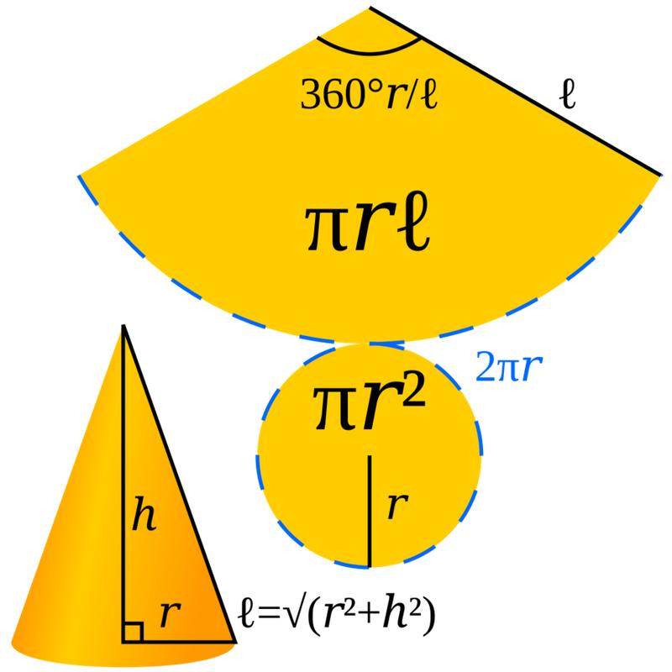
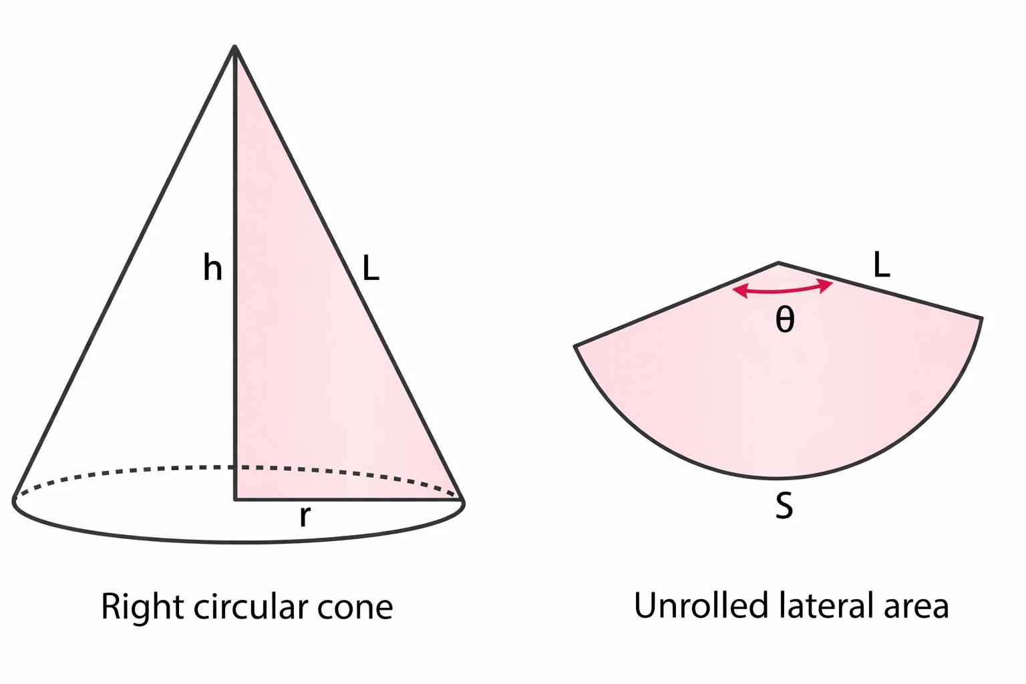
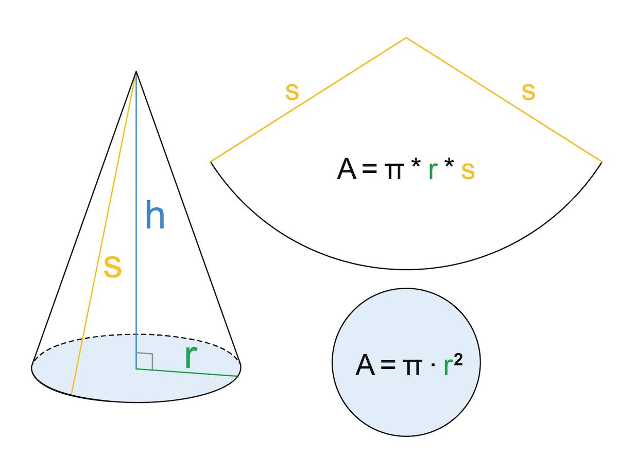
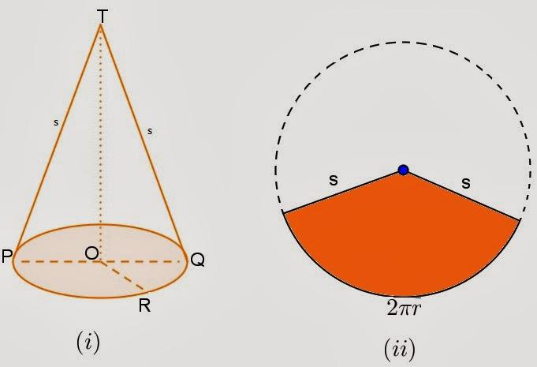
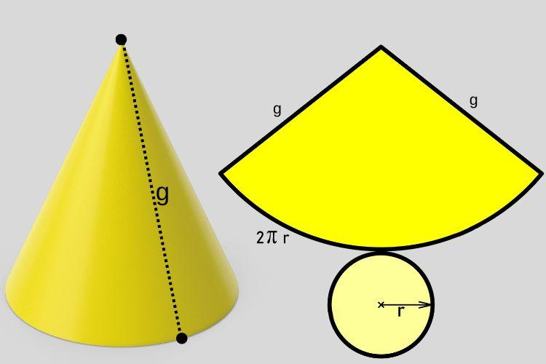
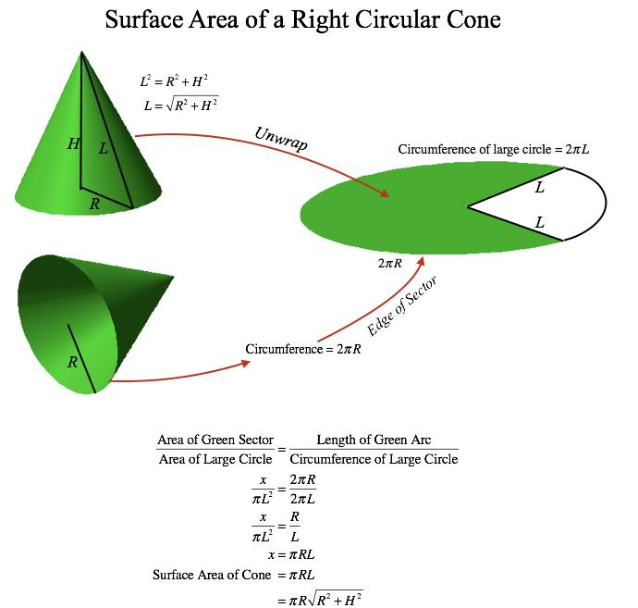
The sector has:
- Radius $l$
- Arc length equal to the circumference of the circular base:
$$2πr$$
The area of the corresponding sector is:
$$\boxed{CSA=πrl}$$

Relationship Between Radius, Height, and Slant Height
# Source: AI Source: Provided by: [Data Path: Persons Table -> ID Column: 1, Name_En Column: Motasem Essam] -> From: [ChatGPT] on [7/20/2026]
For a right circular cone, the radius, height, and slant height form a right triangle:
$$\boxed{l^{2}=r^{2}+h^{2}}$$
Therefore:
$$l=\sqrt{r^{2}+h^{2}} \\ r=\sqrt{l^{2}-h^{2}} \\ h=\sqrt{l^{2}-r^{2}}$$
This relationship is an application of the Pythagorean Theorem.

Main Properties
# Source: AI Source: Provided by: [Data Path: Persons Table -> ID Column: 1, Name_En Column: Motasem Essam] -> From: [ChatGPT] on [7/20/2026]
A conical surface has the following properties:
- It is a curved surface.
- A circular conical surface has a circular directrix.
- All generators meet at one common point—the vertex.
- A right circular cone has a circular base.
- A right circular cone has one vertex.
- The lateral conical surface has one circular boundary curve.
- The lateral surface does not contain the circular base itself.
- The slant height is greater than the perpendicular height for a nondegenerate right cone:
$$l>h$$
- The curved surface area is:
$$CSA=πrl$$
- A finite lateral conical surface is an open surface.

Open and Closed Conical Surfaces
# Source: AI Source: Provided by: [Data Path: Persons Table -> ID Column: 1, Name_En Column: Motasem Essam] -> From: [ChatGPT] on [7/20/2026]
This distinction is important in the classification of surfaces.
Lateral Conical Surface
The curved part alone:
$$\boxed{\text{Conical Surface}=\text{Curved + Open}}$$
It has a circular boundary at the base and does not completely enclose a volume.
Complete Cone Surface
If the circular base is added to the lateral conical surface, the result forms a closed boundary around a three-dimensional region:
$$\boxed{\text{Complete Cone Surface}=\text{Curved + Closed}}$$
Thus, curved/open and curved/closed are not separate geometric-form categories. They are different classification properties.

Examples

Example 1: Finding Slant Height
# Source: AI Source: Provided by: [Data Path: Persons Table -> ID Column: 1, Name_En Column: Motasem Essam] -> From: [ChatGPT] on [7/20/2026]
A right circular cone has:
$$r=3\text{ cm}$$
and:
$$h=4\text{ cm}$$
Using:
$$l=\sqrt{r^{2}+h^{2}} \\ l=\sqrt{3^{2}+4^{2}} \\ l=\sqrt{9+16} \\ l=5$$
Therefore:
$$\boxed{l=5\text{ cm}}$$

Example 2: Finding Curved Surface Area
# Source: AI Source: Provided by: [Data Path: Persons Table -> ID Column: 1, Name_En Column: Motasem Essam] -> From: [ChatGPT] on [7/20/2026]
A cone has:
$$r=5\text{ cm}$$
and:
$$l=12\text{ cm}$$
The curved surface area is:
$$CSA=πrl \\ CSA=π\left(5\right)\left(12\right) \\ \boxed{CSA=60π{\text{ cm}}^{2}}$$
Approximately:
$$\boxed{CSA≈188.50{\text{ cm}}^{2}}$$

Example 3: Finding Total Surface Area
# Source: AI Source: Provided by: [Data Path: Persons Table -> ID Column: 1, Name_En Column: Motasem Essam] -> From: [ChatGPT] on [7/20/2026]
Suppose:
$$r=5\text{ cm}, l=12\text{ cm}$$
Then:
$$TSA=πr\left(l+r\right) \\ TSA=π\left(5\right)\left(12+5\right) \\ TSA=85π$$
Therefore:
$$\boxed{TSA=85π{\text{ cm}}^{2}}$$
Approximately:
$$\boxed{TSA≈267.04{\text{ cm}}^{2}}$$

Types of Conical Surfaces

1. Right Circular Conical Surface
# Source: AI Source: Provided by: [Data Path: Persons Table -> ID Column: 1, Name_En Column: Motasem Essam] -> From: [ChatGPT] on [7/20/2026]
A conical surface whose directrix is a circle and whose axis is perpendicular to the base.
This is the standard cone studied in elementary geometry.

2. Oblique Circular Conical Surface
# Source: AI Source: Provided by: [Data Path: Persons Table -> ID Column: 1, Name_En Column: Motasem Essam] -> From: [ChatGPT] on [7/20/2026]
A conical surface whose directrix is circular but whose axis is not perpendicular to the base.

3. General Conical Surface
# Source: AI Source: Provided by: [Data Path: Persons Table -> ID Column: 1, Name_En Column: Motasem Essam] -> From: [ChatGPT] on [7/20/2026]
A more general conical surface can have a directrix that is not necessarily circular.
The generators still pass through a common vertex.

Conical Surface vs Cone
# Source: AI Source: Provided by: [Data Path: Persons Table -> ID Column: 1, Name_En Column: Motasem Essam] -> From: [ChatGPT] on [7/20/2026]
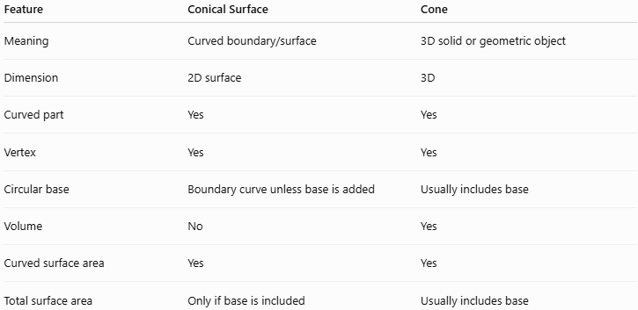
Feature | Conical Surface | Cone
Meaning | Curved boundary/surface | 3D solid or geometric object
Dimension | 2D surface | 3D
Curved part | Yes | Yes
Vertex | Yes | Yes
Circular base | Boundary curve unless base is added | Usually includes base
Volume | No | Yes
Curved surface area | Yes | Yes
Total surface area | Only if base is included | Usually includes base
Therefore:
$$\boxed{\text{Conical Surface}≠\text{Cone Solid}}$$
The conical surface describes the curved boundary, while the cone can refer to the three-dimensional solid enclosed by the conical surface and its base.

Relationship with Other Curved Surfaces
# Source: AI Source: Provided by: [Data Path: Persons Table -> ID Column: 1, Name_En Column: Motasem Essam] -> From: [ChatGPT] on [7/20/2026]
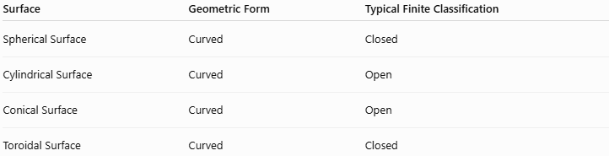
Surface | Geometric Form | Typical Finite Classification
Spherical Surface | Curved | Closed
Cylindrical Surface | Curved | Open
Conical Surface | Curved | Open
Toroidal Surface | Curved | Closed
A conical surface therefore belongs to:
$$\boxed{\text{Surface}→\text{Curved Surface}→\text{Conical Surface}}$$
and its lateral form is also an example of an:
$$\boxed{\text{Open Surface}}$$

Real-World Applications
# Source: AI Source: Provided by: [Data Path: Persons Table -> ID Column: 1, Name_En Column: Motasem Essam] -> From: [ChatGPT] on [7/20/2026]
Conical surfaces are used in:
- Funnels
- Ice-cream cones
- Traffic cones
- Megaphones
- Conical roofs
- Industrial hoppers
- Nozzles
- Some types of lampshades
- Spinning machinery
- Antennas and reflectors
- Engineering components
For example, the amount of material needed to cover the curved outside of a conical funnel can be calculated using:
$$CSA=πrl$$

Advantages
# Source: AI Source: Provided by: [Data Path: Persons Table -> ID Column: 1, Name_En Column: Motasem Essam] -> From: [ChatGPT] on [7/20/2026]
- Provides a simple mathematical model for cone-shaped surfaces.
- Has a straightforward curved-surface-area formula.
- Can be unfolded into a circular sector.
- Has a direct relationship with the Pythagorean Theorem.
- Useful in engineering, architecture, manufacturing, and design.

Limitations
# Source: AI Source: Provided by: [Data Path: Persons Table -> ID Column: 1, Name_En Column: Motasem Essam] -> From: [ChatGPT] on [7/20/2026]
- The formula $CSA=πrl$applies directly to a right circular cone.
- It does not include the circular base.
- Oblique and general conical surfaces may require more advanced methods.
- Real objects may not have perfectly circular bases or perfectly straight generators.

Comparison with Cylindrical Surface
# Source: AI Source: Provided by: [Data Path: Persons Table -> ID Column: 1, Name_En Column: Motasem Essam] -> From: [ChatGPT] on [7/20/2026]
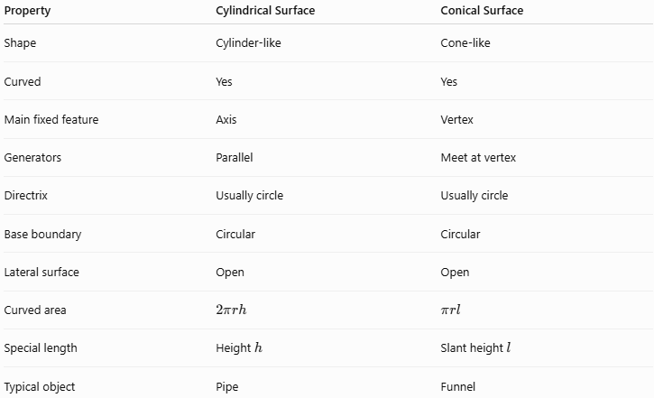
Property | Cylindrical Surface | Conical Surface
Shape | Cylinder-like | Cone-like
Curved | Yes | Yes
Main fixed feature | Axis | Vertex
Generators | Parallel | Meet at vertex
Directrix | Usually circle | Usually circle
Base boundary | Circular | Circular
Lateral surface | Open | Open
Curved area | $$2πrh$$ | $$πrl$$
Special length | Height $h$ | Slant height $l$
Typical object | Pipe | Funnel
The most important structural difference is:
$$\boxed{\text{Cylindrical generators are parallel}}$$
whereas:
$$\boxed{\text{Conical generators meet at one vertex}}$$

Key Points
# Source: AI Source: Provided by: [Data Path: Persons Table -> ID Column: 1, Name_En Column: Motasem Essam] -> From: [ChatGPT] on [7/20/2026]
- A Conical Surface is a curved surface generated by lines passing through a fixed vertex.
- A circular conical surface has a circular directrix.
- A right circular cone has:
  - Vertex
  - Axis
  - Radius
  - Height
  - Slant height
  - Circular base
  - Generators
- The curved surface area is:
$$\boxed{CSA=πrl}$$
- For a right circular cone:
$$\boxed{l^{2}=r^{2}+h^{2}}$$
- The lateral conical surface is open.
- Adding the circular base produces a closed surface.
- A conical surface is not the same as a cone solid.
- Conical surfaces are widely used in engineering, architecture, and everyday objects.

Conclusion
# Source: AI Source: Provided by: [Data Path: Persons Table -> ID Column: 1, Name_En Column: Motasem Essam] -> From: [ChatGPT] on [7/20/2026]
A Conical Surface is a fundamental type of curved surface characterized by generators that pass through a common vertex. In the standard circular case, these generators follow a circular directrix and form the lateral surface of a cone.
For a right circular conical surface, the most important relationships are:
$$\boxed{l^{2}=r^{2}+h^{2}}$$
and
$$\boxed{CSA=πrl}$$
Within the surface classification system, a conical surface is primarily classified by its geometric form as a Curved Surface, while its finite lateral form is also classified by boundary as an Open Surface.

